**Assessment for Day 1**



Person_1

Person_2

***Anne is minded by her babysitter.***

**Q**. Assuming all the similar images (images with two persons only) have been tagged by AI_Image_Tagger with the two Pixel boxes, Person_1 and Person_2, how to enable your Cognitive System to correctly align the Person_1 to “Anne” and the Person_2 to “babysitter”?

You may use the ConceptNet as the knowledge bases and define the rules which are generalisable and programmable.

In order to answer the question, you are expected to:

1. Use *Thematic Role* to represent the caption “*Anne is minded by her babysitter”****.***

*Start with the draft of Thematic Role as below*

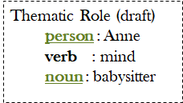

*Apply Rule_A: “Person” belongs to the role “Agent”*

*Then integrate with the KB for Preposition*

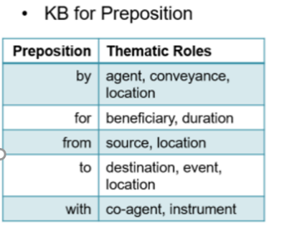

*What will be the complete Thematic Role ?*

Agent: babysitter

Verb: mind (primitive: take care)

Agent: Anne

1. Since the size/area of pixel boxes can be easily calculated, then the fact *sizeofPixel(Persion_1) < sizeofPixel(Person_2)* is true (programmable). If we define the Rule_B based on experience as follow:

Rule_B: SizeOfPixel (babysitter) > SizeOfPixel(Anne)

Then the alignment is reasoned out already as:

Babysitter = Person_2, Anne=Person_1.

However, the rule_b is too specific and it cannot be generalized to other captions/pictures.

Could you **modify the “Rule b”** to make it more generalisable? Remember that the modified “Rule_b” will be eventually used together with a Knowledge Graph constructed from [*ConceptNet*](http://conceptnet.io/)*,* in order toreason out the alignment. Thus please **construct the Knowledge Graph** based on *ConceptNet* and integrate with Rule_b to **explain how** the alignment can be finally reason out.

Knowledge Graph

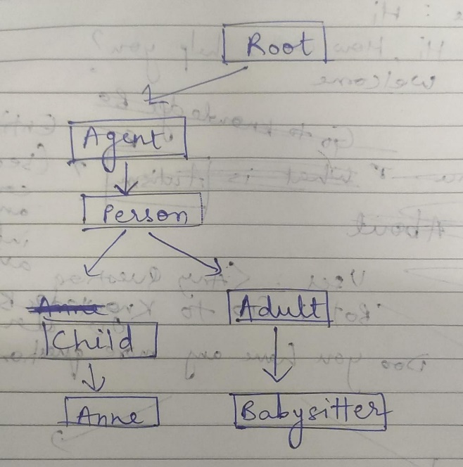

Rule_b: IsChild(Anne) and IsAdult(babysitter) and

AgeOfPerson(Anne)< AgeOfPerson(babysitter)

Then babysitter = Person_2 and Anne = Person_1